New California State
Constitutional Convention 7
October 15-17, 2020
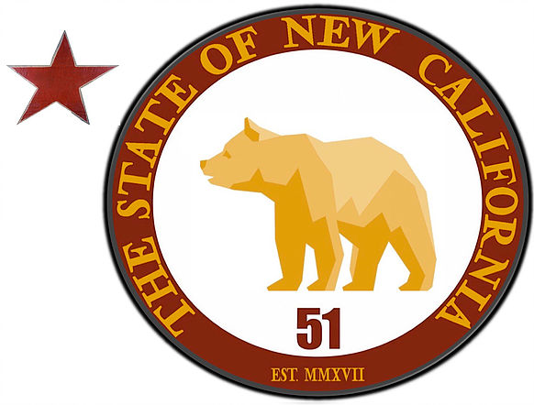
Fresno, CA
Workshops

Voter Registration
Election Fraud
Social Media/building email lists

Fund raising
How to create a message
Gaining Support for New California from President Trump
Gaining Support for New California from Members of California’s Congressional Candidates
Working with California State Assembly Members
Working with California State Senators
Article IV, Section 4
Republican Form of Government
Free from Invasion
Free from Domestic Violence
Grievances
Recruiting. Vetting and Developing Memberships
Outreach to Communities/General public Malcolm McGough
These workshops will be spread over three days
Meetings, Town Hall, Rally, Store Fronts, March to Rally, Hong Kong, Open California, Save California, New California

